**Solutions Calculator Club**

**Project Documentation**

**Clock Module**

**Clock Module Circuit Function**:

Three configuration of 555 timer circuits:

1. The First timer circuit is the Astable Clock that runs the clock trigger for the other ICs in the other modules.
2. The second is the Mono Stable configuration of the 555 timer that is the manual trigger of the clock pulse.
3. The third 555 timer Circuit is the Bi Satable mode that toggles between the two other modes Astable and MonoStable.

There is a potentiometer that controls the RC time constant of the Astable Clock. This can vary the Pulse to a maximum of 300 hz. It is advisable to run the clock in manual mode unless the program in memory will run automatically.

The Clock Module uses combinational logic to connect 3 separate 555 timer circuits:

74LS04 (Hex Inverter)

74LS08 (Quad AND gate)

74LS32 (Quad OR gate)

The User defines the Clocks Operating Mode to Manual or Automatic Clock Cycling.

**INPUTS;**

Power for the IC’s VCC pin

Halt (HLT) IN Stops the Clock when the Control Logic issues the opt code.

**OUTPUTS:**

Pin 3 on the 555 Timer ICs.

**NOT CLK**

This is the output of an inverter pin 12

**CLK**

This is the output from pin 8 of the AND input of a pin 8 inverted HLTsignal and a pin 3 of an OR gate. The Astable CLK Timer circuit is AND with the BiStable Timer circuit output the both must be high to output the Astable Clock Signal. Else the Toggle is set for manual trigger of the MonoStable Timer Circuit.

**Ground**

**LEDs** indicate the value when high.

**Clock Circuit Schematic**:.

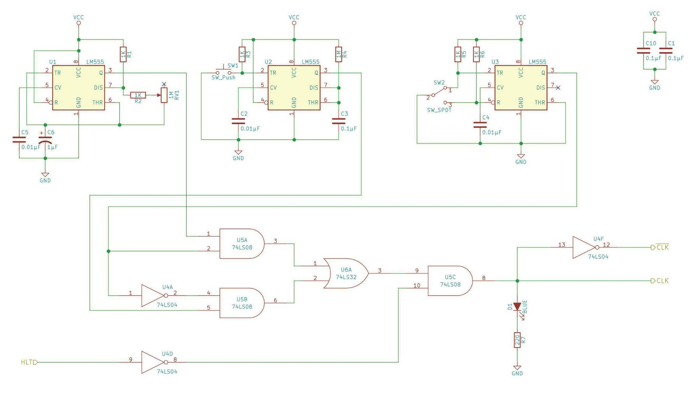

**Clock Parts List**:

| Clock Module: | | | | | |
| --- | --- | --- | --- | --- | --- |
|  | QN | QIn | **DigiKey Part Number** | **Description** | **Alternate Part** |
|  | 1 |  | 1988-1060-ND | Breadboard |  |
|  | 3 |  | LM555CNNS/NOPB-ND | [555 timer](https://eater.net/datasheets/lm555.pdf) IC | LM555CN/NOPB (8) |
|  | 1 |  | 296-1629-5-ND | [74LS04 Hex inverter](https://eater.net/datasheets/74ls04.pdf) |  |
|  | 1 |  | 296-1633-5-ND | [74LS08 Quad AND gate](https://eater.net/datasheets/74ls08.pdf) |  |
|  | 1 |  | [74LS32](https://eater.net/datasheets/74ls32.pdf)  296-2062-ND | [74LS32 Quad OR gate](https://eater.net/datasheets/74ls32.pdf) | CD4071BE |
|  | 6 |  |  | 1kΩ resistor |  |
|  | 1 |  |  | 220Ω resistor |  |
|  | 1 |  |  | Blue LED |  |
|  | 3 |  |  | 0.01µF capacitor |  |
|  | 3 |  |  | 0.1µF capacitor |  |
|  | 1 |  |  | 1µF capacitor |  |